TITLE EXAMPLE - INTERACTIONS BETWEEN CLIMATOLOGICAL VARIABLES IN UBERLÂNDIA (state of minas gerais): A CASE STUDY

(Note: The names and affiliations of the authors should only be added after the article has been accepted, but they must all be entered into the journal’s system (METADATA) when submitting the article, as the inclusion of authors after the article has been accepted will not be permitted)

First author
E.g.: Federal University of Uberlândia, Institute of Geography, Uberlândia, state of Minas Gerais, Brazil
email_address@domain.com

Second author
E.g.: Federal University of Uberlândia, Institute of Geography, Uberlândia, state of Minas Gerais, Brazil
email_address@domain.com

RESUMO
Must contain a concise presentation of the research in a single paragraph, highlighting the objective, method, results, and conclusions of the article. The alignment must be justified, indentation on the left and right of 1.5 cm. It must not present citations, formulas, equations, diagrams, or symbols. Its length must be between 100 and 200 words, with single spacing between lines, and Arial font size 9. In the case of texts submitted in English and Spanish, an abstract must be made in the language of the text, and the resumo in Portuguese.
Palavras-chave: Three to five. Separated by point. Initial capitals. Followed by a period. Do not repeat words already used in the title.

TITLE IN A FOREIGN LANGUAGE (ENGLISH OR SPANISH)

ABSTRACT
It should faithfully translate the resumo. Authors will be able to choose whether they want to translate into English or Spanish. The translation must be carried out by a qualified translator rather than online translators available on the internet. Just like the resumo, its length must be between 100 and 200 words, formatted with Arial font size 9, single line spacing, and paragraph alignment justified with an indent on the left and right of 1.5 cm.
Keywords: Translation of palavras-chave. Separated by point. First letter capitalized. Followed by a period.

To complete the guidelines, please consult the Submissions and About the Journal sections.
The file must be formatted according to this model, including headers, footers, and line numbering.
Manuscripts must be sent in a version compatible with Microsoft Word and must contain a minimum of 10 and a maximum of 20 pages, considering all their content.
Remove any type of identification in the submitted text (names of authors, collaborators, laboratories, departments, and institutions to which they are linked, funding agency numbers, and project titles).
The manuscript must contain the following structure:
Text;
Final considerations;
Acknowledgments (when necessary);
References.

TEXT
General text formatting
Paragraphs without indentation, Arial font size 10, with single line spacing, space before and after paragraphs of 6 pts, top and left margins 3cm and bottom and right 2cm, with continuously numbered lines.
All links in the text, including in the References section, must be active.
Sections
The text of the article may be divided into sections (not numbered, in capital letters and in bold; e.g. INTRODUCTION, METHODOLOGY, RESULTS, AND DISCUSSION) and subsections (not numbered, with capital only in the first letter and in the proper names, in bold and italics; e.g. Study area).
The first section will always be the INTRODUCTION. This section should contain the objectives, hypotheses (if any), and justification for the work.
Numbers
Write out the numbers from one to nine, except for measurements (e.g.: five people, nine students, 6 m, 9 km², 10 m, 23° C). Separate decimal places with commas (e.g.: 0.13) and numbers with more than four digits with periods (e.g.: 10,000).
For quantities, use the International System of Measurements.
Latitude and longitude are expressed as: 10° 34' 21" N, 14° 26' 12" W.
Formulas and equations
They must be highlighted in the text, aligned to the left, and numbered with Arabic numerals in parentheses (if there is more than one), aligned to the right. Example:
$a^{2}+b^{2}=c^{2}$ (1)
$A=πr^{2}$ (2)
Foreign words and acronyms
Use italics for foreign words such as e.g., i.e., cf., ca, n.b., apud, post-hoc, and sensu (do not use italics for 'vs.' and 'etc.').
Cite the name followed by the acronym the first time the expression appears in the text. After that, just use the acronym. E.g.: "Brazilian Institute of Geography and Statistics (IBGE)".
Citations
For all software mentioned in the text, it must include: if it is commercial, its license information; if it is free, you must mention this information in the text; software must also be included in the references.
Do not include consulted links directly in the text. They must be included in the list of references and cited in the text appropriately.
For citations throughout the text, use the following formatting: One author: Ab'Saber (1990) or (Ab'saber, 1990). Two authors: Silva and Ramirez (1992) or (Silva; Ramirez, 1992). Three authors: Lima, Mendes and Santos (2017) or (Lima; Mendes; Santos, 2017). Four or more authors: Silva et al. (1992) or (Silva et al., 1992).
Use semicolons to separate citations from different authors (Silva; Ramirez, 1992; Ramirez, 1993) or for multiple citations from the same author (Ab'saber, 1990; 1993a; 1993b). Present multiple citations in chronological order (Ab'saber, 1990; Silva; Ramirez, 1992; Ab'saber, 1993)
For long direct citations, use the following formatting: 4cm indent, single spacing, Arial size 9, separated from the upper and lower text by 6 pt spacing. (Author, year, page).
Preparation of Figures
Photographs, drawings, graphs, images, maps, etc. will all be called figures. The elements inside the figures must all be readable. Figures must be inserted into the text as images and not imported from Excel or other software. The figures, as well as their captions, must be positioned where they will be published.
Regarding maps, they must contain the basic elements of cartography standards (title, orientation, legend, scale, and cartographic projection).

Top text (Figure 1)...

Figure 1 – The title (centered, Arial font size 10) must contain the following elements, in this order: Location – description of the figure – date. Titles must not be inside the Figures (they must be at the top of the figure, in text form, as per the example below).
E.g.: Figure 1 – Municipality of Uberlândia (state of Minas Gerais, MG): Altimetry, 2020
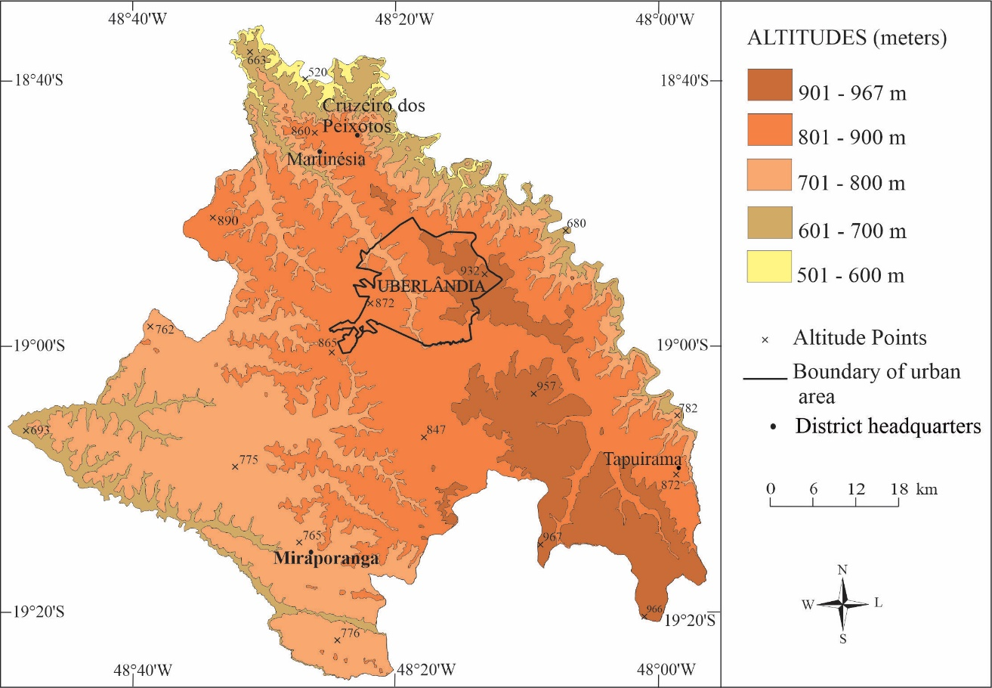
Sources: IBGE, 2015; UBERLÂNDIA, 2018. Preparation or Organization: the authors, 2020. (centralized, Arial 9 font size)
If the exposed data was produced by the authors:
E.g.: Source: The authors, 2020.
If the exposed data was collected from a secondary source:
E.g.: Source: IBGE, 2015. Preparation or organization: The authors, 2020.
The sources of the figures must appear in the references.

Bottom text…

Preparation of tables
They should not be saved as images. They are used for quantitative data and must have open sides.
Top text (Table 1)...

Table 1 - Uberlândia (MG): Areas of occupation in the municipal public service, 2015
AREAS | 2011 |  | 2012 | 2013 | TOTAL
Human | 5 |  | 12 | 9 | 26
Physical | 10 |  | 8 | 3 | 21
Medical | 3 |  | 1 | 6 | 10
TOTAL | 18 |  | 21 | 13 | 57
Sources: IBGE, 2015; UBERLÂNDIA, 2018. Preparation or Organization: the authors, 2020. (centralized, Arial 9 font size)
If the exposed data was produced by the authors:
E.g.: Source: The authors, 2020.
If the exposed data was collected from a secondary source:
E.g.: Source: IBGE, 2015. Preparation or organization: The authors, 2020.
The sources of the tables must appear in the references
Bottom text...

Top text (Table 2)...

Table 2 - Uberlândia (MG): Geoenvironmental characteristics of the Lagoinha Stream, 2016
 | Factor |  | Category
 | Slope |  | 0 – 2 %
 |  |  | 2 – 12%
 |  |  | 12 – 30%
 |  |  | 30 – 100%
 |  |  | > 100%
 | Erosion |  | No
 |  |  | Low
 |  |  | Intermediate
 |  |  | High
Soil |  | Very fertile
 |  | Fertile
 |  | Moderately fertile
 |  | Not very fertile
Sources: IBGE, 2015; UBERLÂNDIA, 2018. Preparation or Organization: the authors, 2020. (Centralized, Arial 9 font size)
If the exposed data was produced by the authors:
E.g.: Source: The authors, 2020.
If the exposed data was collected from a secondary source:
E.g.: Source: IBGE, 2015. Preparation or organization: The authors, 2020.
(Centralized, Arial 9 font size)
The sources of the tables must appear in the references

Bottom text...

Preparation of boxes
They should not be saved as images. They are used for qualitative data, predominantly filled with words, and must be closed on the sides.
Box 1 - Cartographic Conventions
Themes | Conventions
1 – Hydrography  1.1 – Perennial watercourses  1.2 – Intermittent watercourses | Color: Blue  Single or double lines  Dashed lines
2 - Highways | Color: red, and white  Red and white solid or dashed lines
3 – Railways | Color: Black  Continuous lines cut vertically with short straight segments
4 – Plant cover | Color: green  Regular or irregular, continuous or not continuous areas
5 – Limits | Color: Black  Dashed, dotted, or mixed lines
Source: ALBUQUERQUE, 2020. Adaptation: the authors (Centralized, Arial 9 font size)
If the exposed data was produced by the authors:
E.g.: Source: The authors, 2020.
If the exposed data was collected from a secondary source:
E.g.: Source: IBGE, 2015. Preparation or organization: The authors, 2020.
The sources of the boxes must appear in the references.

Bottom text...

FINAL CONSIDERATIONS
After the text of the article, the authors must prepare their final considerations. They must be brief and answer the research questions raised in the introduction, corresponding to the objectives and hypotheses, point out the main contributions of the research, and present recommendations for future work.
ACKNOWLEDGEMENTS
The acknowledgments section is mandatory for works that have received resources from government funding agencies (FAPEMIG, FAPESP, CAPES, CNPq, MEC, MCTI, etc.), for those whose authors have received research, extension, master's and/or doctorate scholarships, as well as for those carried out with the authorization of government bodies (IBAMA, ICMBIO, Municipal Secretariats, etc.). For other works, the acknowledgments section is optional.
Thanks to people who contributed to the execution of the work and who do not meet the authorship criteria (according to CRediT authorship papers) can also be listed.
To ensure the impersonality of the evaluation process, the names of collaborators, laboratories, departments, and institutions, funding agency numbers, and project titles must only be inserted in the final version of the article.
REFERENCES
References should only include works that were mentioned in the text. References must be complete and precise, aligned to the left, with single line spacing, 6 pt space between paragraphs, and Arial font size 10. Highlights must be in bold.
Works must be listed in alphabetical order, not numbered.
Authors MUST add the DOI number of those references that have it. To check which references have a DOI, access the website https://apps.crossref.org/SimpleTextQuery, copy and paste the references in the appropriate space and click on ‘Submit’. Wait for the result and copy the DOIs. Additionally, all links must be active.
Examples of references:
ÁVILA, M. B. Direitos sexuais e reprodutivos: desafios para as políticas de saúde. Cadernos de Saúde Pública, Rio de Janeiro, v. 19, p. 465-469, 2003. https://doi.org/.
BRASIL. Medida Provisória nº 2.230, de 8 de setembro de 2001. Available at https://www.planalto.gov.br/ccivil_03/MPV/Antigas_2001/2230.htm Accessed on: Sep 04, 2008.
FREYRE, G. Casa grande & senzala: formação da família brasileira sob regime de economia patriarcal. Rio de Janeiro: J. Olympio, 1943. 2 v. https://doi.org/.
FREYRE, G. Sobrados e mucambos: decadência do patriarcado rural no Brasil. São Paulo: Ed. Nacional, 1936. https://doi.org/.
GARCIA, M. L. C.; NAGEM, J. F. Fronteira amazônica: violência e unidades especiais de defesa. In: SIMPÓSIO BRASILEIRO DE SENSORIAMENTO REMOTO, 19., 2019, Santos-SP. Anais […]. São José dos Campos: INPE, 2019. p. 2220-2222. Available at http://marte2.sid.inpe.br/rep/sid.inpe.br/marte2/2019/09.03.18.19. Accessed on: Oct 20, 2020.
INPE - Instituto Nacional de Pesquisas Espaciais. Portal do Monitoramento de Queimadas e Incêndios. 2014. Available at http://www.inpe.br/queimadas. Accessed on: Mar 28, 2014. https://doi.org/.
MINAYO, M. C. S.; GOMES, S. F. D. R. (Org.) Pesquisa social: teoria, método e criatividade. 30 ed. Petrópolis: Vozes, 2011. (Coleção Temas Sociais). https://doi.org/.
SANTOS, M. A metrópole: modernização, involução e segmentação. In: VALLADARES, L.; PETRECEILLE, E. (Coord.) Reestruturação urbana: tendências e desafios. São Paulo: Nobel, 1990. p. 183-191. https://doi.org/.
SÃO PAULO (Estado). Secretaria do Meio Ambiente. Diretrizes para a política ambiental do Estado de São Paulo. São Paulo, 1993. https://doi.org/.
SOUZA, E. B. C. Estado: produção da região do Lago de Itaipu - turismo e crise energética. Thesis (Doctorate in Geography) – Presidente Prudente: UNESP. 2002. https://doi.org/.
UBERLÂNDIA. Secretaria de Planejamento Urbano. Banco de Dados Integrados – BDI 2019. Vol. 1. Available at http://docs.uberlandia.mg.gov.br/wp-content/uploads/2019/10/BDI-2019-vol1.pdf. Accessed on: May 5, 2020.

In cases that were not covered by the rules described above, authors must follow the current ABNT standards:
* References - Preparation (NBR 6023);
* Citations in documents – Presentation (NBR 10520);
* Abstract – Presentation (NBR 14724).
* We suggest consulting the Guia online para normalização de publicações técnico-científicas da EDUFU (available at http://www.edufu.ufu.br/catalogo/ebooks-gratuitos/guia-para-normalizacao-de-publicacoes-tecnico-cientificas)

