Title in Portuguese using Cambria font, size 18

Title in English using Cambria font, size 14

Title in Spanish using Cambria font, size 14

Authors in Cambria, italic, size 12

ABSTRACT
Abstract in Cambria 10, single spacing, left margin indent of 1, and right margin indent of 1. When the original article is in Portuguese or English, the first abstract will be in Portuguese, the second in English, and the third in Spanish. When the original is in Spanish, the first abstract will be in Spanish, the second in English, and the third in Portuguese.

Keywords: Keywords; Keywords; Keywords.

RESUMO
Resumo em Cambria 10, espaçamento 1, recuo de parágrafo à esquerda de 1 e recuo à direta de 1. Resumo em Cambria 10, espaçamento 1, recuo de parágrafo à esquerda de 1 e recuo à direta de 1. Resumo em Cambria 10, espaçamento 1, recuo de parágrafo à esquerda de 1 e recuo à direta de 1.

Palavras-chave: Palavras-chave; Palavras-chave; Palavras-chave.

RESUMEN
Resumen en Cambria 10, espacio 1, sangría izquierda 1, sangría derecha 1; Resumen en Cambria 10, espacio 1, sangría izquierda 1, sangría derecha 1; Resumen en Cambria 10, espacio 1, sangría izquierda 1, sangría derecha 1.

Palabras clave: Palabras clave; Palabras clave; Palabras clave.

1 Introduction
Body text in Cambria 12, 1.5 line spacing, Body text in Cambria 12, 1.5 line spacing, Body text in Cambria 12, 1.5 line spacing, Body text in Cambria 12, 1.5 line spacing, Body text in Cambria 12, 1.5 line spacing; Body text in Cambria 12, 1.5 line spacing, Body text in Cambria 12, 1.5 line spacing.

2 Subtitles, if necessary
2.1 Subsection, if necessary
Body text in Cambria 12, 1.5 line spacing, Body text in Cambria 12, 1.5 line spacing, Body text in Cambria 12, 1.5 line spacing, Body text in Cambria 12, 1.5 line spacing, Body text in Cambria 12, 1.5 line spacing; Body text in Cambria 12, 1.5 line spacing, Body text in Cambria 12, 1.5 line spacing.

Block quotation in Cambria 11, single spacing, with a 4 cm left indent; Block quotation in Cambria 11, single spacing, with a 4 cm left indent; Block quotation in Cambria 11, single spacing, with a 4 cm left indent (CITATION, 2017, p. xxx)

Excerpt in Cambria 12, single spacing, with a 2.0 cm left indent; Excerpt in Cambria 12, single spacing, with a 2.0 cm left indent; Excerpt in Cambria 12, single spacing, with a 2.0 cm left indent;

Chart

Chart 1 – Cambria font, size 11, centered

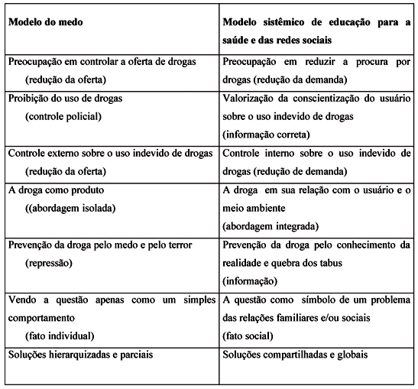

Source: Cambria font, size 10, centered

Table
Table 1 – Cambria font, size 11, centered

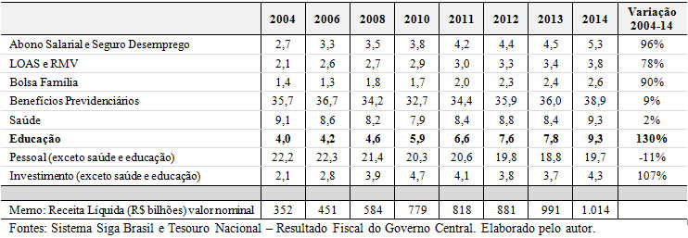

Source: Cambria font, size 10, centered

Figure
Figure 1- Cambria font, size 11, centered

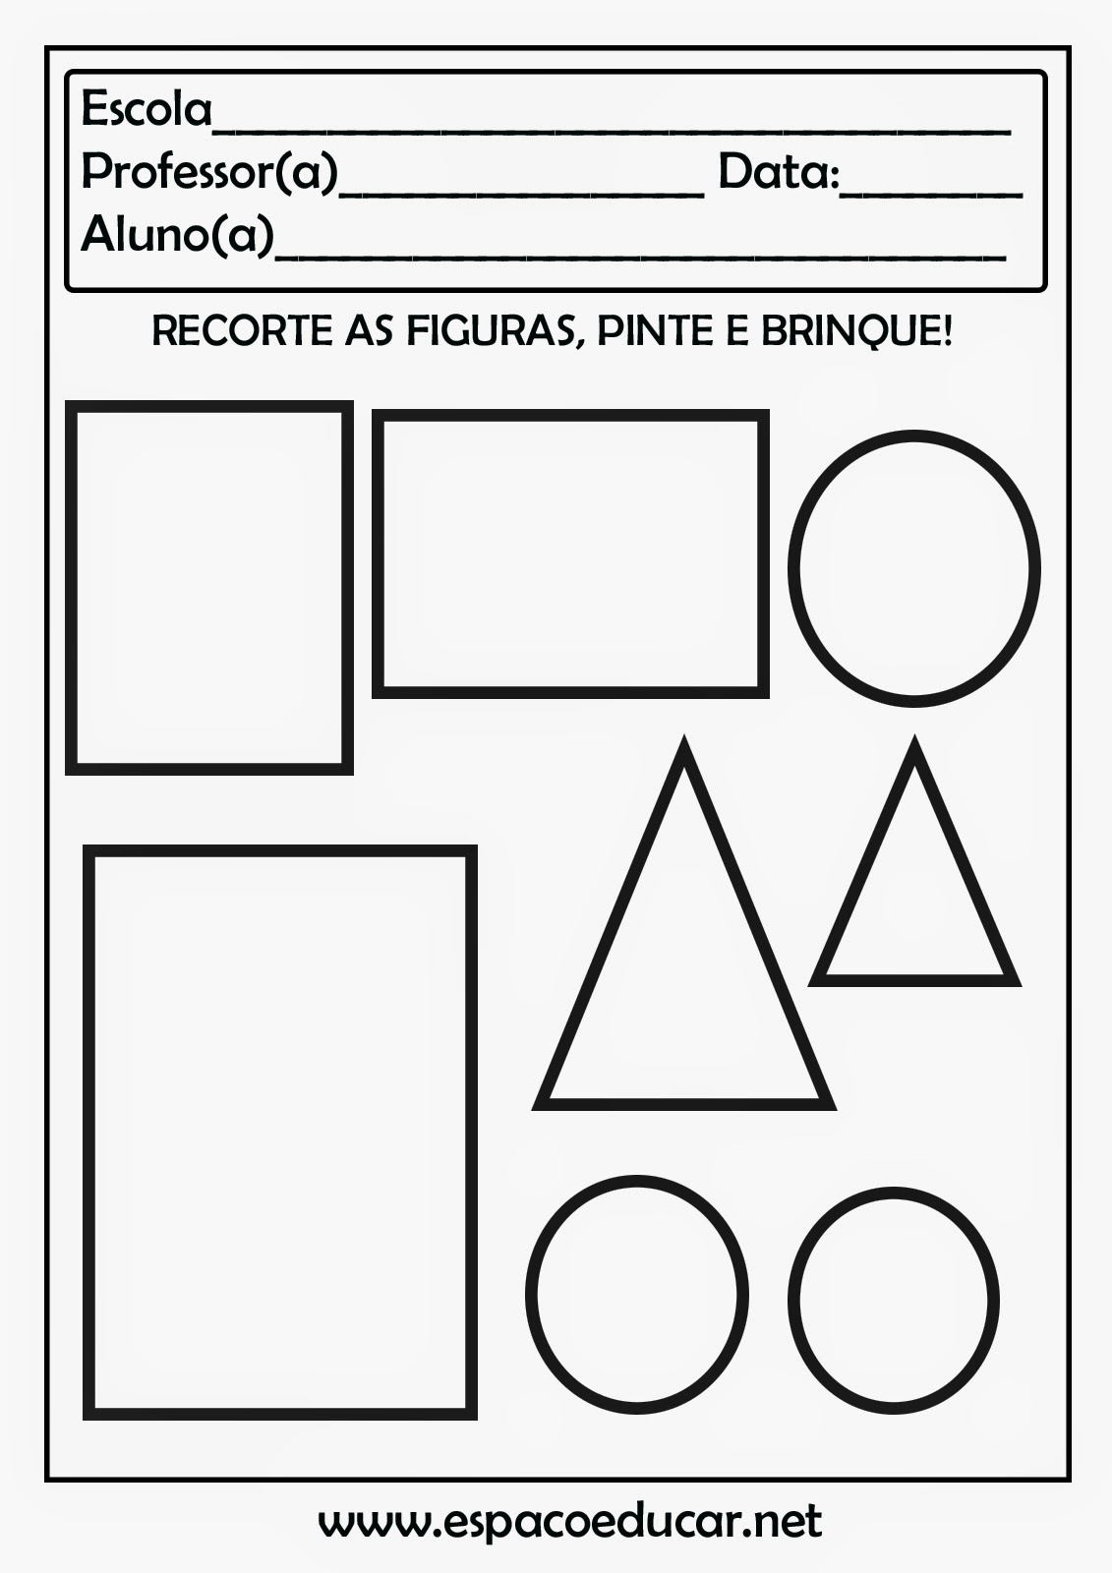

Source: Cambria font, size 10, centered

3 Final considerations
These are always syntheses of arguments previously addressed, briefly reviewing them and presenting the results and conclusions. When dealing with research or academic work, the final considerations are the last part of the text.
Body text in Cambria 12, 1.5 line spacing, Body text in Cambria 12, 1.5 line spacing, Body text in Cambria 12, 1.5 line spacing, Body text in Cambria 12, 1.5 line spacing, Body text in Cambria 12, 1.5 line spacing; Body text in Cambria 12, 1.5 line spacing, Body text in Cambria 12, 1.5 line spacing.

4 References
References must be presented: flush-left (no indent), in alphabetical and chronological order, indicating the works cited in the text, following ABNT standards. Following the references, it is optional to include a bibliography, listing consulted or recommended works that were not cited in the text, also in alphabetical and chronological order, following ABNT standards.

In the case of works (journal articles, dissertations, theses, among others) with a DOI, it must be included in the references as a active link.

Bellow are some examples:

DAVIDOV, V. V. (org.). Desenvolvimento da psique no processo de atividade de estudo escolar cuja edição esteve a cargo. Moscou, 1983. (fonte Century Schoolbook, tamanho 12, espaçamento simples)

DAVIDOV, V. V. A historia do ensino desenvolvimental (O Sistema D. B. Elkonin-V. V. Davidov). Parte I. Вестник, № 1, 1996b. Disponível em: http://www.experiment.lv/rus/biblio/vestnik_1/v1_davidov_iz_istorii.htm. Acesso em:xxxxxxxxx.

DAVIDOV, V. V. La enseñanza escolar y el desarrollo psíquico. Moscú: Editorial Progreso, 1988.

PASQUALINI, J. C; MARTINS, L. M. Dialética singular-particular-universal: implicações do método materialista dialético para a psicologia. Psicologia & Sociedade, v. 27, n. 2, p. 361-370, 2015. DOI: https://doi.org/10.1590/1807-03102015v27n2p362.

Received: month/year (Cambria font, size 10, single line spacing)
Accepted: month/year

In the English version, include the name and email address of the translator.
Author details in Cambria 10, footnote. Graduate Program in XXXXXXX, Brazil. ORCID: xxxxxxxx; Email: xxxxxxxxx@universidade.br.

